How you download and send assignments on Edmodo
The entire time you are in my class we will be using Edmodo for different assignments. It is important that you know how to download the assignment to complete, and then how to turn in the assignment for credit.
- Log into Edmodo and find the assignment | 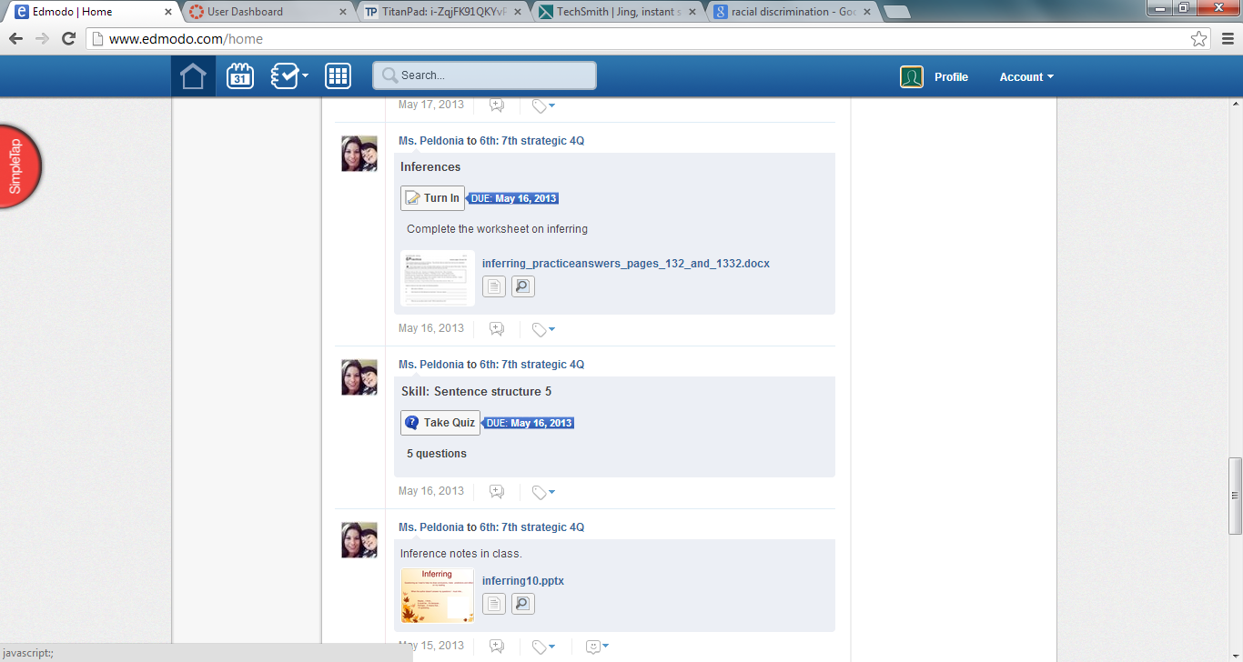
- Clink the turn in button on the assignment | 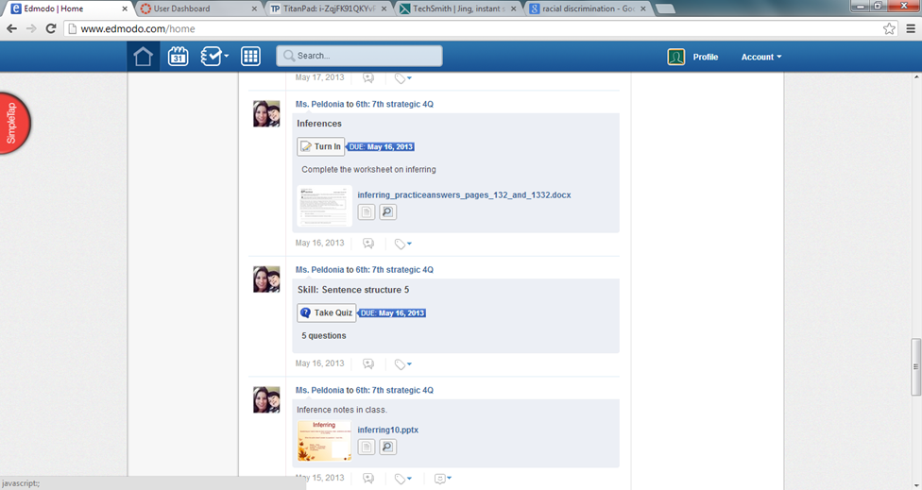
- Click to download the assignment | 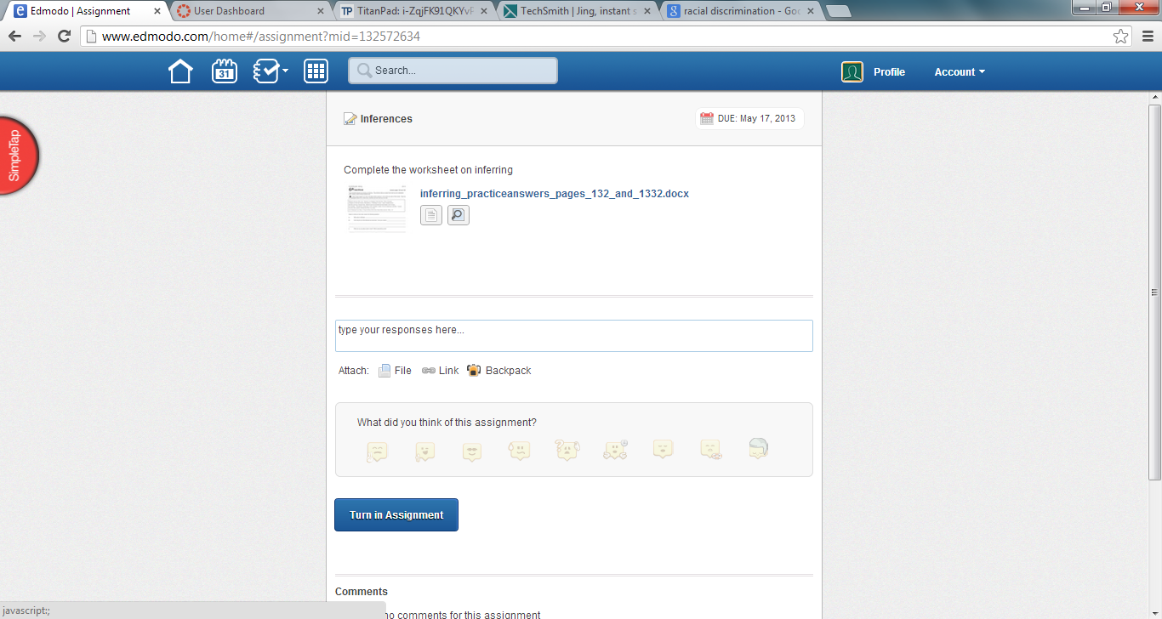
- Now click to download the assignment to word | 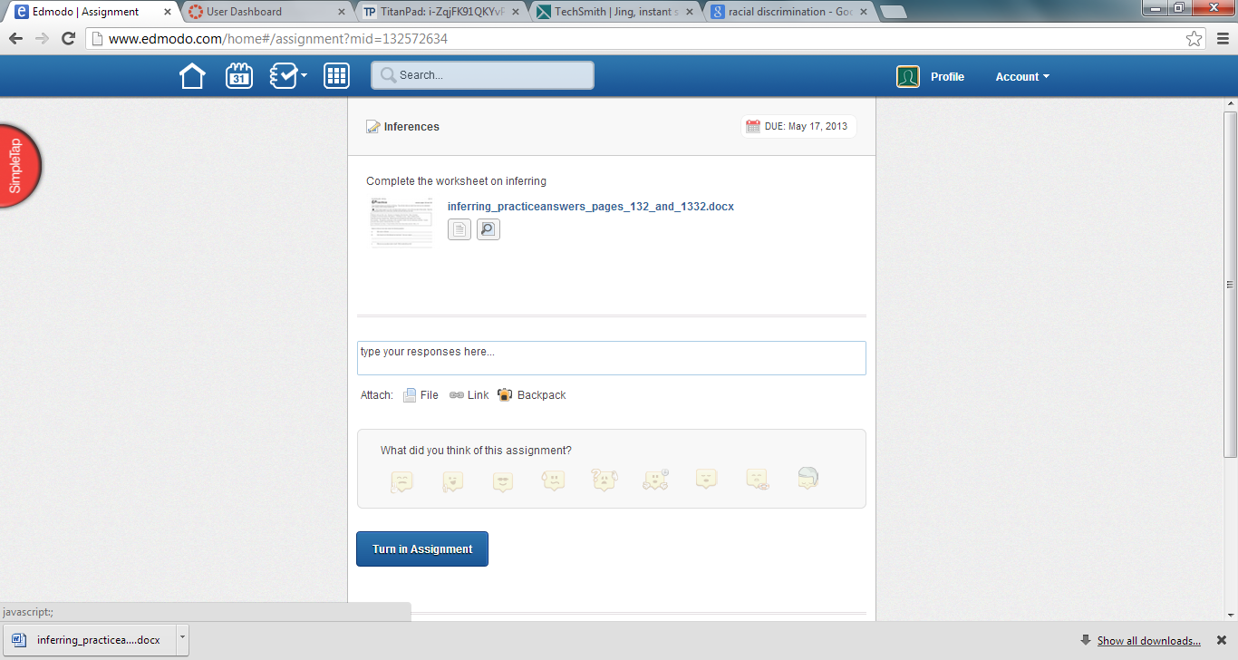
- Once the assignment is downloaded you need to enable editing | 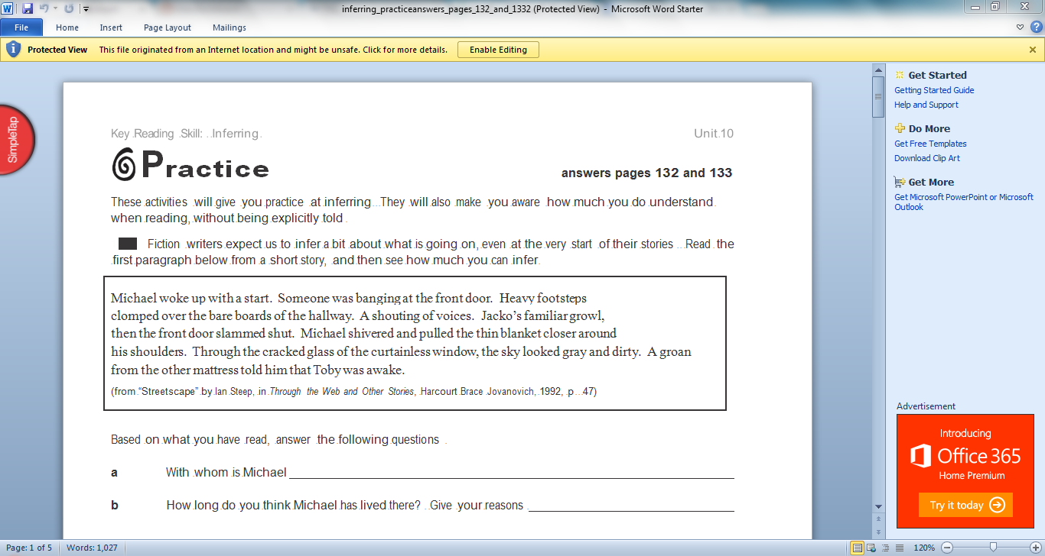
- Now complete the assignment. (lines may move when you type, this is fine as long as I can read it) | 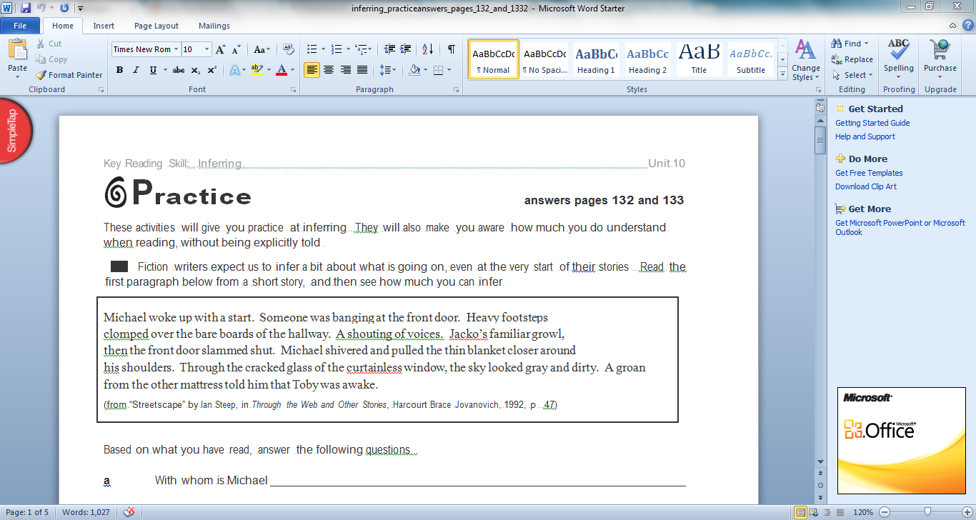
- Once you have finished the assignment you need to save it. Click on File
- Click on Save As | 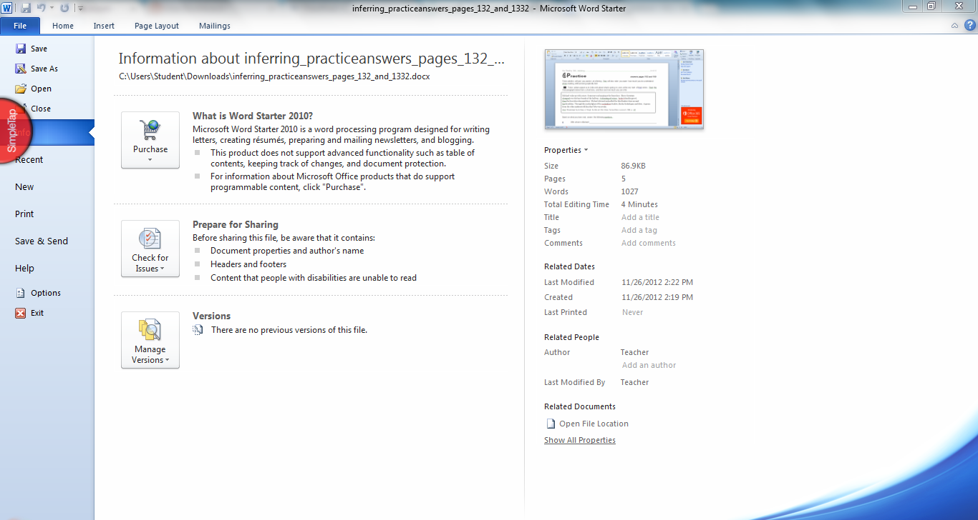
- Click on desktop, or type it in the bar that says users> Student> Downloads | 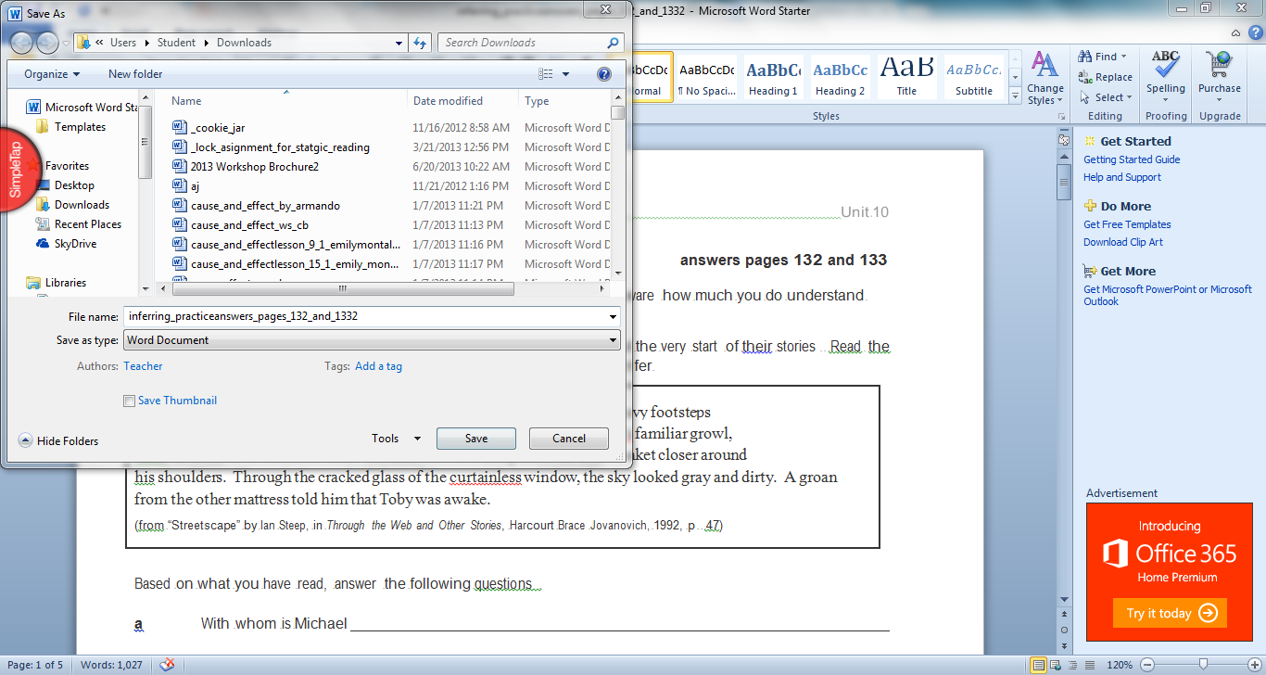
- Find your class period folder. (so if you are in my 1st period class you would find period 1) | 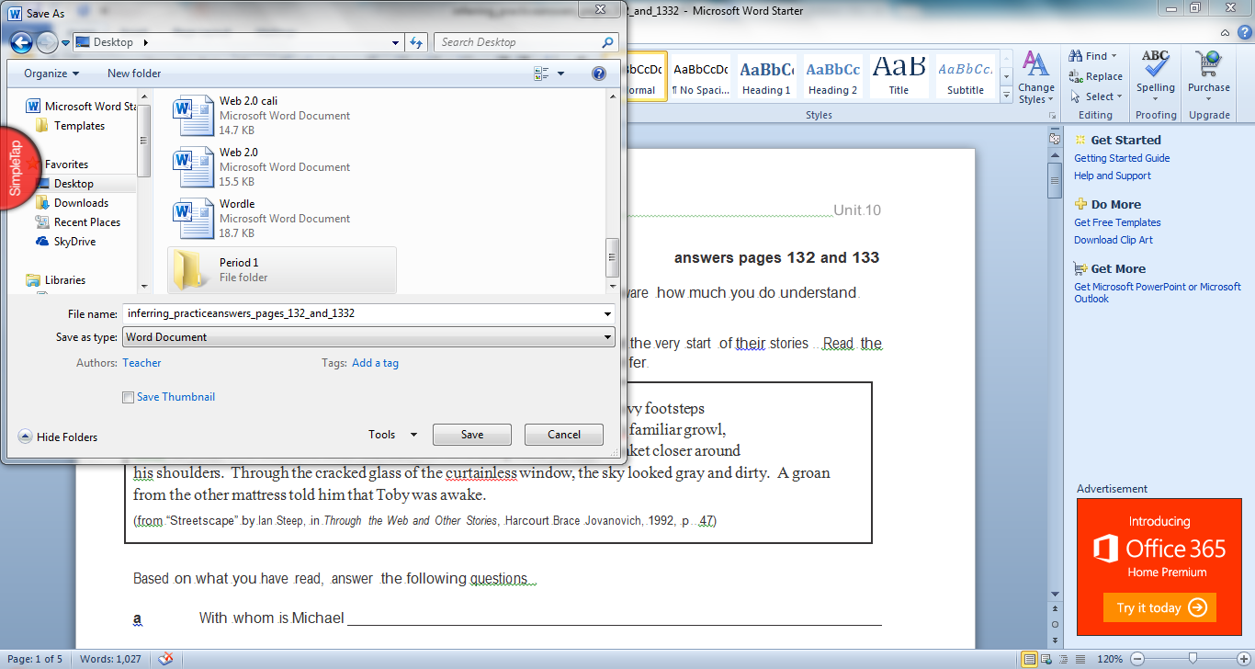
- Now name your document, keeping it the same name is easiest. Then click save | 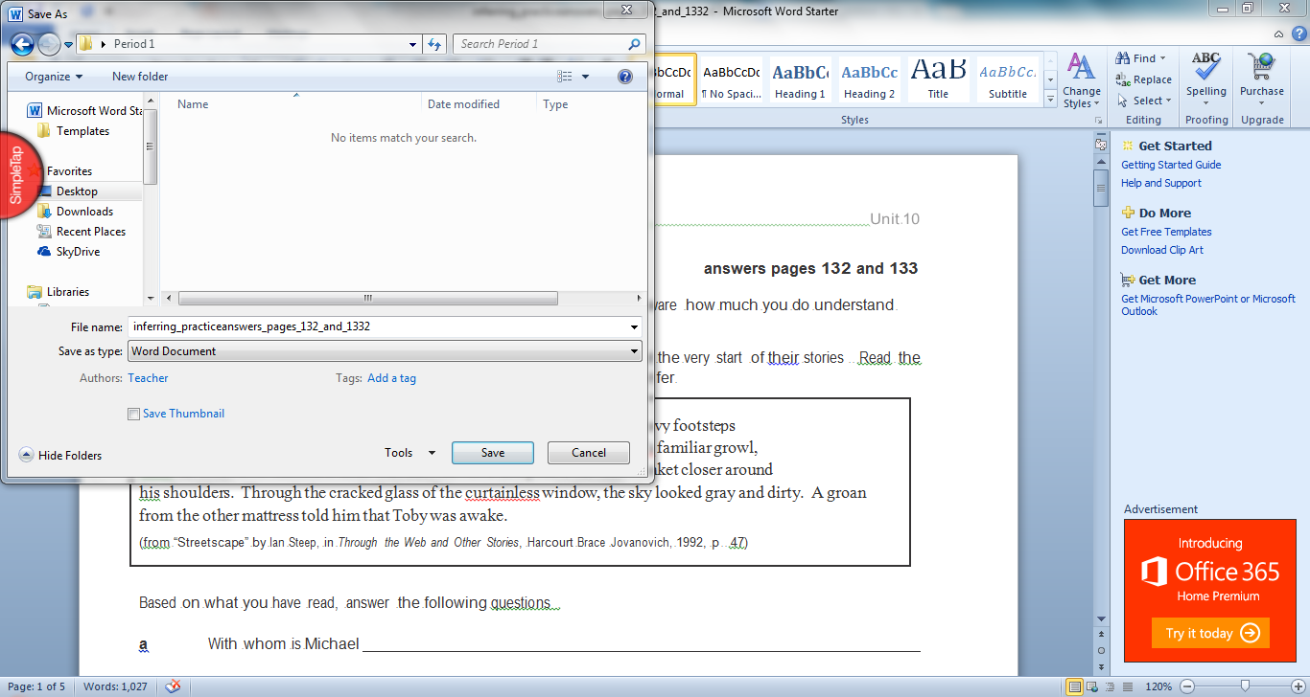
- Go back to Edmodo, click on File
- Find Desktop, or type desktop in the bar at the top SkyDrive> Documents> Reading | 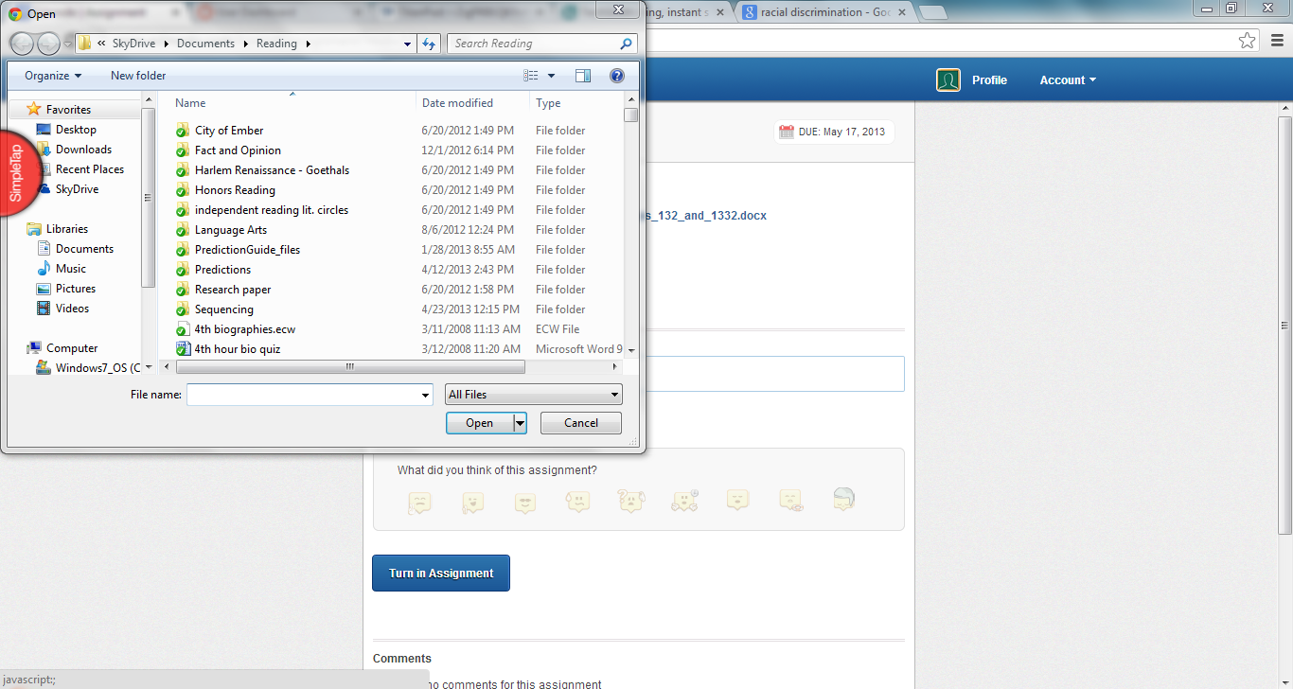
- Find your class period file you saved your paper under | 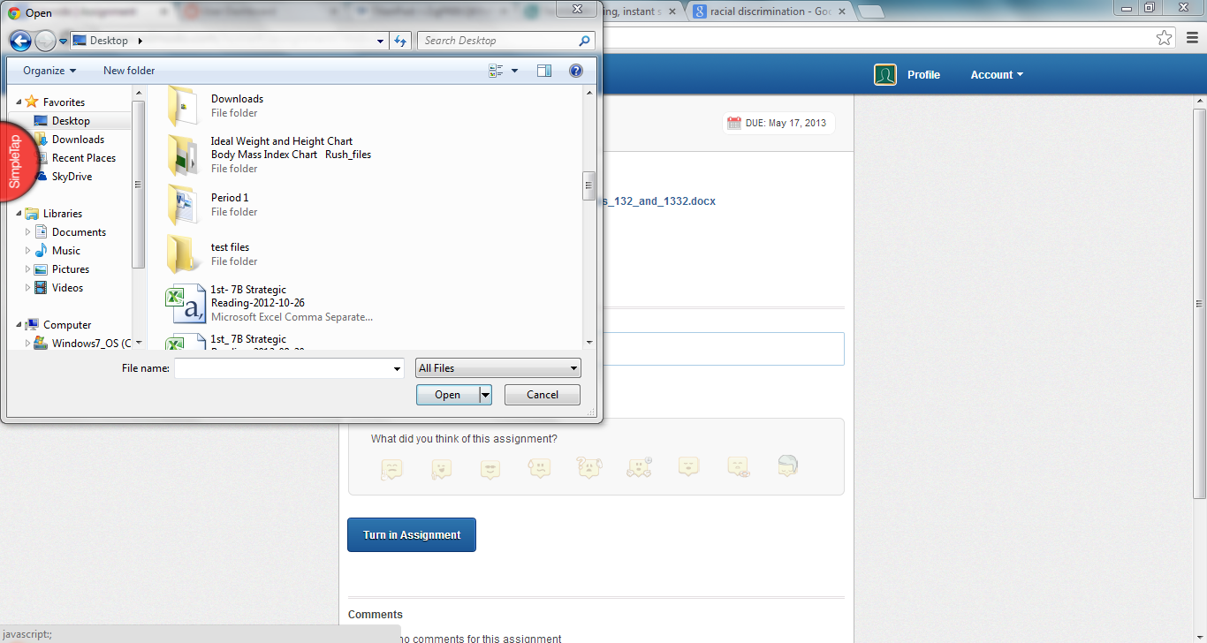
- Now find your assignment under the name you saved it as.  Click open | 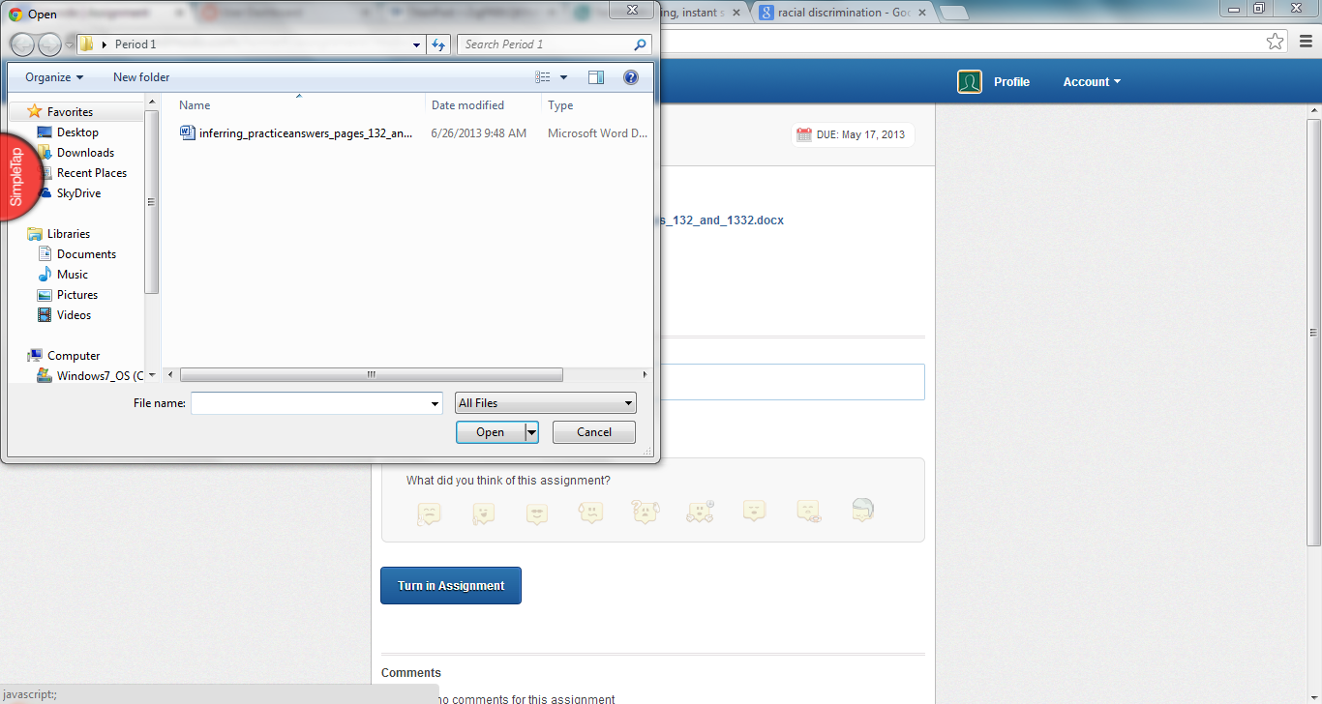
- Make sure you have the red X that shows your file is attached | 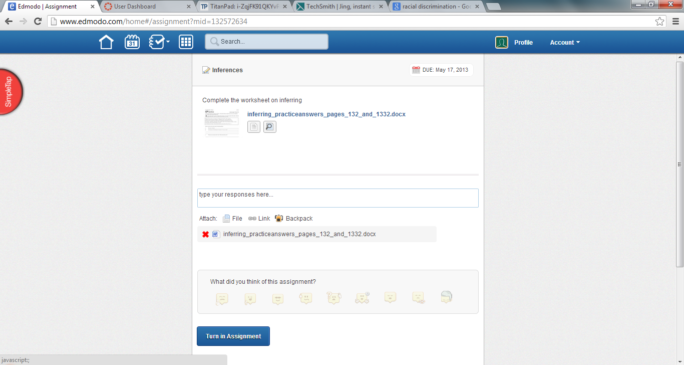
- Click on a face that shows how you felt about the assignment, then click Turn in Assignment | 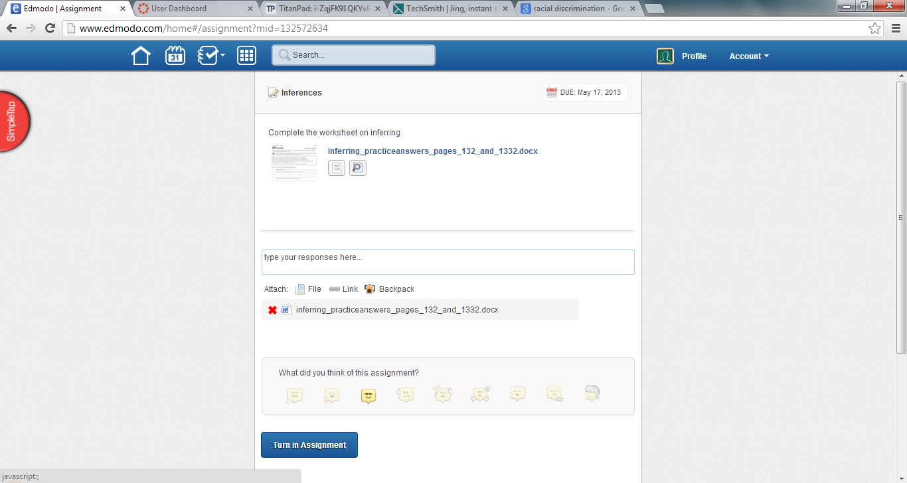
- Make sure your assignment was attached | 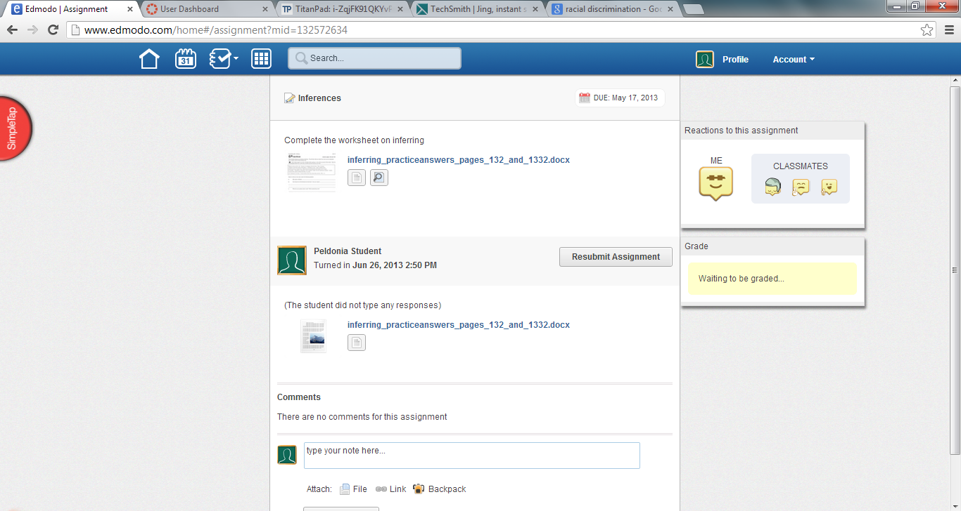
- You have now downloaded and turned in an assignmnet | 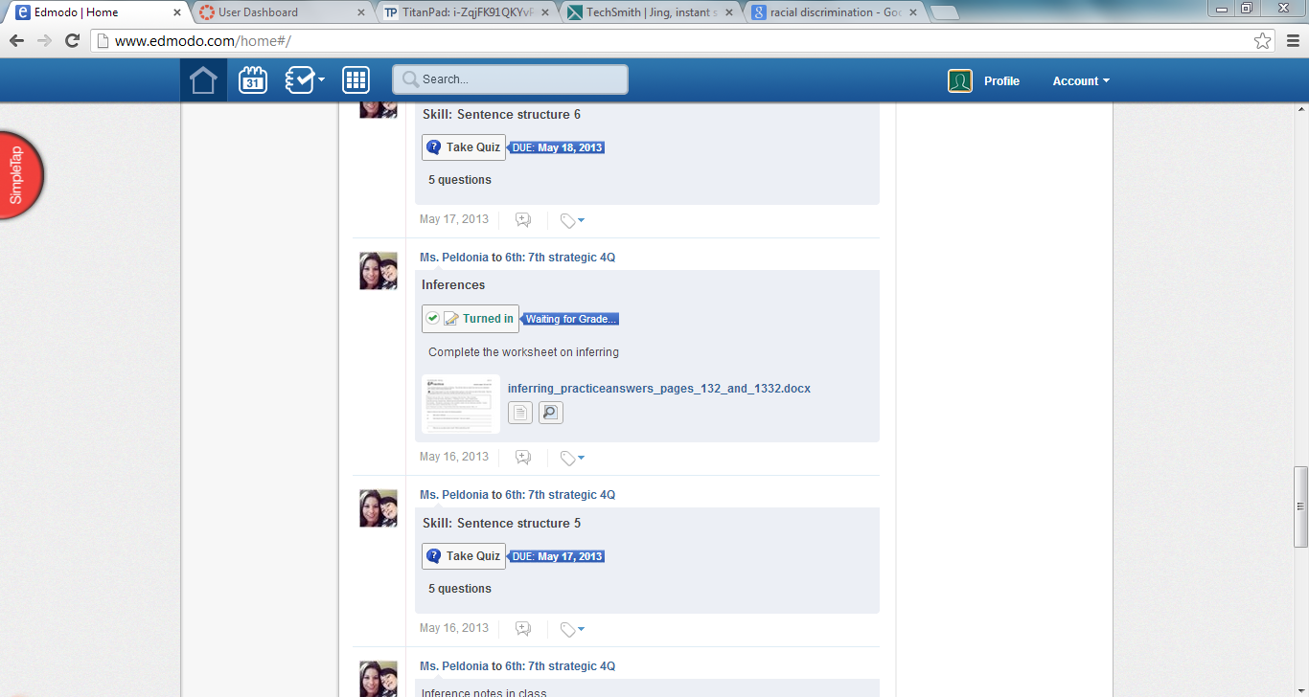

Edmodo is a tool that can be used on every level of Blooms taxonomy. It is a resource that helps put everything in one place and allows for the teacher to keep everything in one place for the students. The level used is completely up to the teacher by what they include or use on edmodo. Edmodo engages students, improves communication between teacher and students, and reduces the amount of paper used in class. I find it one of the best ways to help keep students on task and the students seem to accept it more because it is very much like Facebook. Edmodo is “giving teachers and students access to our curriculum through a private social learning network is a unique opportunity to put digital literacy and citizenship lessons into practice” (Edmodo). They have one particular place to start and to always come back to. I send assignments, directions, as well as test and quizzes through this website. The students know what to expect and it has helped with the little parts of classroom management. I have been showing other teachers how great this website it and really recommend it to other teachers. “Through Edmodo's free and secure social network, teachers have access to the Digital Citizenship community. The community is loaded with resources designed to spark conversations in virtual and physical classrooms about how to engage safely and smartly with technology” (Edmodo). Edmodo allows for the teacher to individualize learning without putting focus on the difference. “Web 2.0 is well suited to active, personalized and meaningful learning and collaborative knowledge building” (Virkus, pg 480). Edmodo is a great Web 2.0 tool because it does offer the socialization and personalized learning to each student. I have learned and connected with many other educators around the world to see what they are doing in their classrooms. I am still learning all the capabilities of this amazing website.
I choose to do a step-by-step table with images to make it easier for the students to see what buttons to click and the steps to follow. This allows them to see the computer screen and have the button highlighted so they know exactly what to do. I make screen shots from the student’s computers so everything is set up exactly the same. I didn’t want there to be any confusion with added or altered buttons.

Edmodo; common sense media and edmodo team up to bring K-12 digital literacy and citizenship lessons to schools nationwide. (2012). Education Letter, 41.
Virkus, S., & Bamigbola, A. A. (2011). Students' conceptions and experiences of web 2.0 tools. New Library World, 112(11), 479-489. doi:http://dx.doi.org/10.1108/03074801111190473

